ESP32
GND ==> GND
3V3 ==> 3V3/3.3V
DC ==> GPIO25
CS2 ==> GPIO23
CS1 ==> GPIO22
CLK ==> GPIO32
SDA ==> GPIO33
RST2 ==> GPIO5
RST1 ==> GPIO16

If you want to modify the pins ==> Open the User_Setup.h file in the TFT_eSPI folder
Find the location shown below and modify
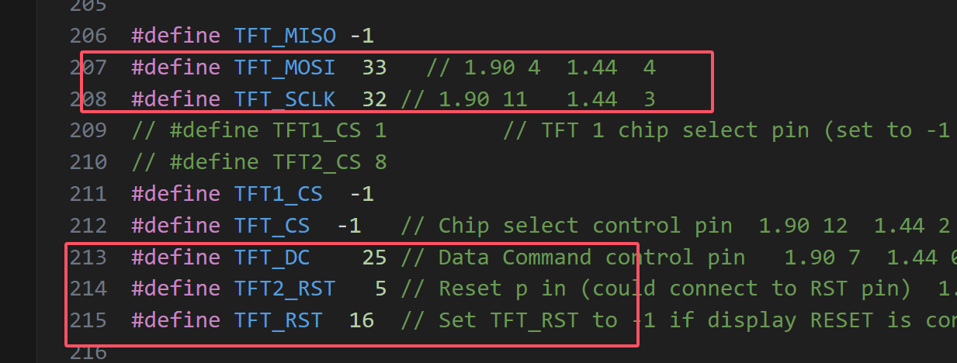
Open the project Animated_Eyes_2.ino, check the config.h file, and modify the definition of the position in the figure below
